ONLINE FOOD ORDERING SYSTEM
Project Document
Submitted By:
• Alisha Kamran (Registration No:l1f23bscs1052)
• Affifa Sajjad (Registration No: l1f23bscs0298)
• Wahaj Nasir (Registration No l1f23bscs0402)

Description:
The Online Food Ordering System is a website made to make food ordering and delivery easy. It lets users view restaurant menus, choose food, place orders, and track delivery. The system uses tree nodes to store menus, linked lists to manage orders, queues for handling delivery tasks, stacks for order history, and trees to organize restaurant data. These data structures help the system run fast and smoothly.

Table of Contents
I. Introduction …………………………………………………… 1
II. Objectives …………………………………………………… 2
III. Scope and Limitations ……………………………………. 3
IV. Flowchart ……………………………………………………4
V. Conclusion ……………………………………………………5
VI. References ………………………………………………….. 6

Introduction
The Online Food Ordering System is a website made to make food ordering easy and fast. It lets users check restaurant menus, pick food, pay safely, and track their delivery using a simple interface. The system uses arrays to save menu items, linked lists to manage orders, queues for delivery, stacks for order history, and trees for restaurant data. This project helps connect customers and restaurants in a better and smoother way.

Objectives
1. To develop a user-friendly web platform for customers to browse menus, place orders, and make secure payments.
2. To implement efficient data structures, including arrays, linked lists, and hash tables, for menu management, order processing, and user authentication.
3. To provide real-time order tracking and effective communication between customers and restaurants.

Scope and Limitations

Scope
This project is about making a website for food ordering. It includes user sign-up, viewing menus, placing orders, making payments, and tracking deliveries. It uses the right data structures to make everything work well.

Limitations
• The system is restricted to web-based access, excluding mobile app functionality.
• It supports a limited number of restaurants in the initial implementation.
• Real-time delivery tracking relies on third-party API availability.

Flowchart
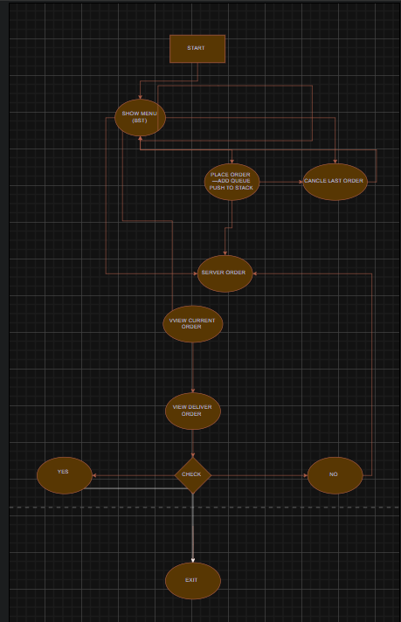
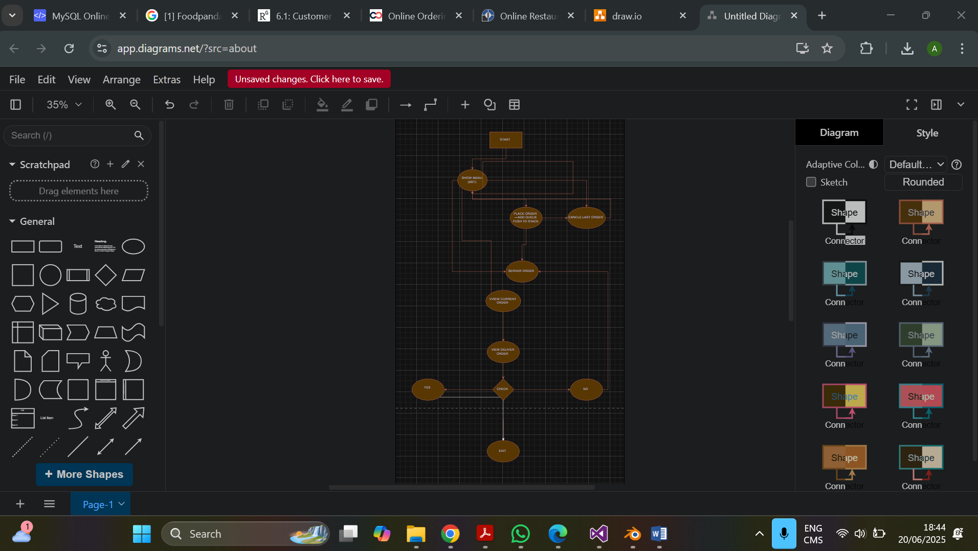

Conclusion
The Online Food Ordering System provides an efficient and user-friendly solution for food ordering and delivery. By applying data structures such as queue, linked lists, and tree, stack, the system ensures optimal performance in menu management, order processing, and user authentication. Future upgrades could include mobile app integration and expansion to include more restaurants, further improving its accessibility and scalability.

References
[1] Foodpanda, “How Online Food Ordering Works,” [Online]. Available: https://www.foodpanda.com/how-it-works. [Accessed: June 20, 2025].
[2] Uber Eats, “Technology Behind Food Delivery,” [Online]. Available: https://www.ubereats.com/technology. [Accessed: June 20, 2025].
[3] A. Smith and B. Johnson, “Efficient Data Structures for Online Food Ordering Systems,” in IEEE Transactions on Software Engineering, vol. 47, no. 3, pp. 123-130, Mar. 2024.

